Murray's Cove, The Discography (v15), 1965-2012

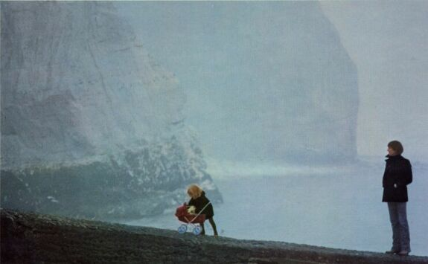

Foreword to Version 15

The skeleton of this discography was generated automatically by Murray's Cove, a comprehensive* database (in MS Access) of Murray's recordings to date. Throughout, songs/tracks are hyperlinked in blue/purple (the links only work on my PC – sorry!) while sources/albums are listed in red. Additional information is given in black.

Key recordings – the best of the best, about 80 songs in total – are marked  (original source / first time only), while absolute must-haves – the best of the best of the best, plus that Bangkok song, about 40 songs in total – are marked with a red-hot . Only my opinion, of course – please feel free to delete them!

*I have only included singles containing songs that are/were unavailable on albums eg. recordings from the 60s, alternative versions (Heaven, Bangkok...), that sort of thing. Otherwise, the list would have been truly endless. Run a search on google or ebay for “murray head” to see what I mean.

I’ve also decided to include a completely useless list of my favourite ‘Murraygrams’, the result of a lifelong obsession with anagrams and, sadly, having nobody with whom to share them.

Finally, many thanks to Karen Topinka for her help with the initial input. All comments, corrections, etc. gratefully received at mjc2002@hotmail.com.
Mike Church
Aretxabaleta
November 2012

1965 Cocaine Blues
Solo
Earliest known recording. Demo single. Non-album A-Side. No B-Side.

 1965 Cocaine Blues (G.Davis)

1965 Alberta / He Was A Friend Of Mine
Solo
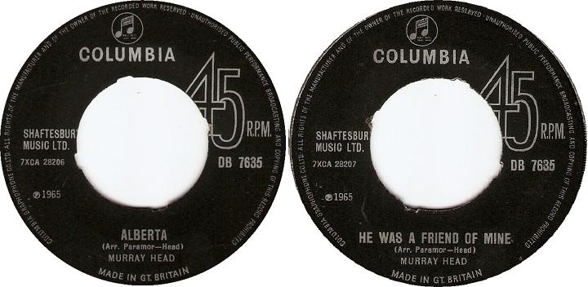

1st single. Non-album A- & B-Sides.

1965 Alberta (B.Dylan)
Incorrectly credited to Norrie Paramor and Murray!
1965 He Was A Friend Of Mine (Trad.)
B-Side. Don't confuse this with The Byrds' "adaptation" which is totally different.

1965 The Bells Of Rhymney / Don't Sing No Sad Songs For Me
Solo
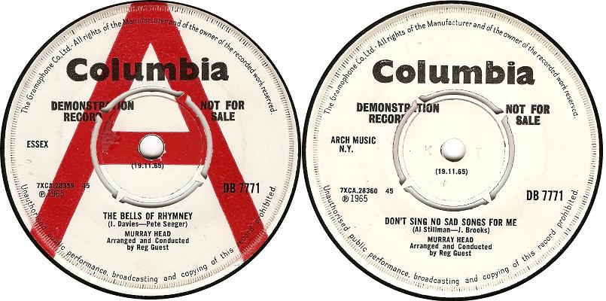

2nd single. Non-album A- & B-Sides.

 1965 The Bells Of Rhymney (P.Seeger-I.Davies)
 1965 Don't Sing No Sad Songs For Me (A.Stillman-J.Brooks)
B-Side.

1966 Hot Pops
Various Artists
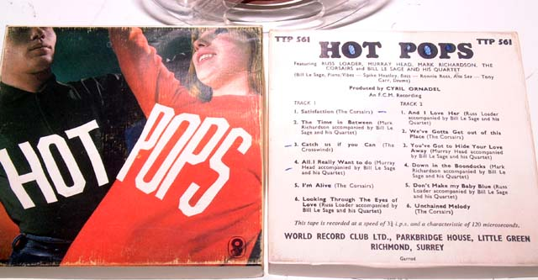

Cover versions of popular songs.

 1966 All I Really Want To Do (B.Dylan)
 1966 You've Got To Hide Your Love Away (J.Lennon-P.McCartney)

1966 Top Pop Song Hits Vol II
Various Artists
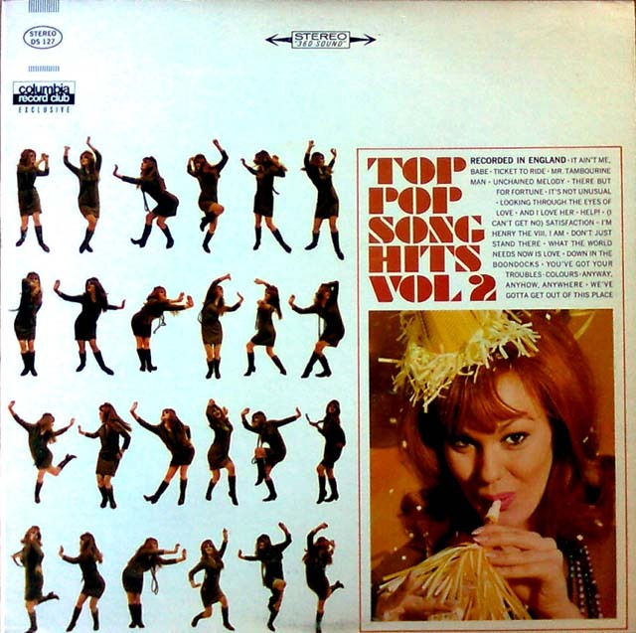

Cover versions of popular songs. Issued by Columbia.

1966 Colours (D.Leitch)

Aka Donovan
 1966 It Ain't Me Babe (B.Dylan)

1966 The Family Way
Various Artists
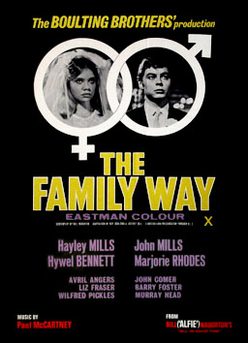

Directed by Roy Boulting. Murray’s first film role.

1966 Someday Soon (M.Head)
3rd single A-Side. (B-Side = You Bore Me).
1966 It's Time You Went (M.Head)

1967 Someday Soon / You Bore Me
Solo
3rd single. Non-album A- & B-Sides.

1966 Someday Soon (M.Head)
Featured in The Family Way
1967 You Bore Me (M.Head)
B-Side. With The Blue Monks

1967 She Was Perfection / Secondhand Monday
Solo
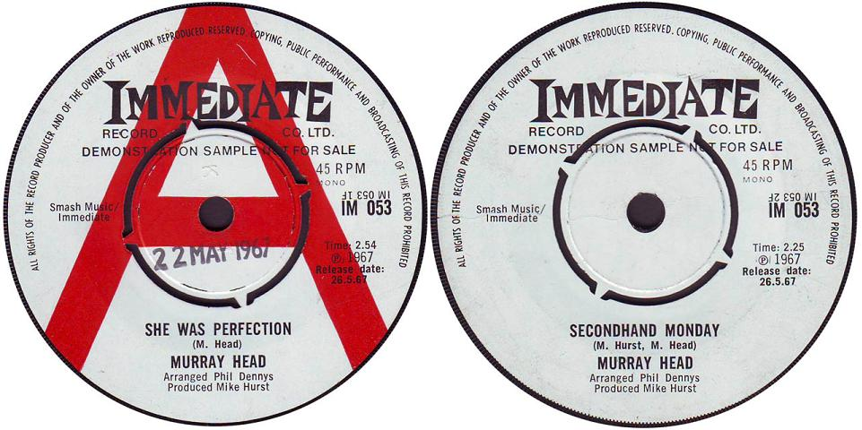

4th single. Non-album A- & B-Sides.

 1967 She Was Perfection (M.Head)
The melody reappeared five years later on Religion (Nigel Lived).
1967 Secondhand Monday (M.Head-M.Hurst)
B-Side.

1967 Diminishing Perspective
Solo

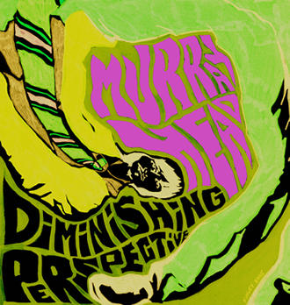

Co-written by Murray Head and Barry Dennen in 1967. Instrumentation added by Scott
Kuchler in 2002. Never released.

1967-2002 Diminishing Perspective (M.Head-B.Dennen-S.Kuchler)
1967-2002 Yes We Can (M.Head-B.Dennen-S.Kuchler)
WANTED!
1967-2002 Wait For Me (M.Head-B.Dennen-S.Kuchler)
WANTED!
1967-2002 Do I Love Her? (M.Head-B.Dennen-S.Kuchler)
WANTED!
1967-2002 Yours Sincerely (M.Head-B.Dennen-S.Kuchler)
 1967-2002 Celestial City (M.Head-B.Dennen-S.Kuchler)
 1967-2002 Nightbird (M.Head-B.Dennen-S.Kuchler)
1967-2002 Run To The Night (M.Head-B.Dennen-S.Kuchler)

1969 Heaven On Their Minds
Solo
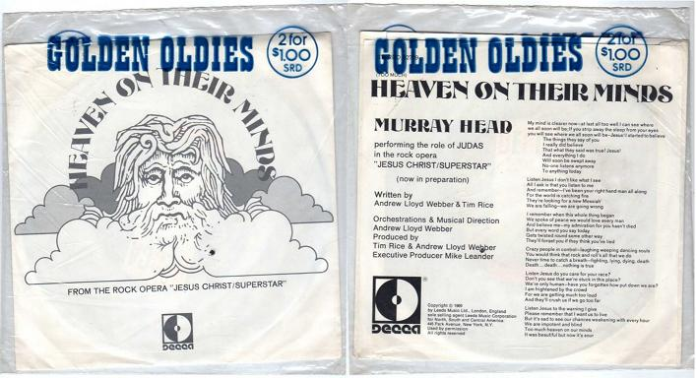

7" single. Non-album A-Side. Different to the version on Jesus Christ Superstar.

1969 Heaven On Their Minds [Single] (T.Rice-A.Lloyd Webber)
1969 Strange Thing Mystifying [Instrumental] (A.Lloyd Webber)
B-Side filler.

1970 Jesus Christ Superstar (LP)
Various Artists

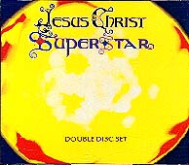

Soundtrack to show of same name by Tim Rice and Andrew Lloyd Webber.

 1970 Heaven On Their Minds (T.Rice-A.Lloyd Webber)
1970 Strange Thing Mystifying (T.Rice-A.Lloyd Webber)
With Ian Gillan
 1970 Everything's Alright (T.Rice-A.Lloyd Webber)
With Yvonne Elliman
 1970 Damned For All Time / Blood Money (T.Rice-A.Lloyd Webber)
 1970 The Last Supper (T.Rice-A.Lloyd Webber)
With Ian Gillan
1970 Gethsemane (T.Rice-A.Lloyd Webber)
With Ian Gillan
 1970 Judas' Death (T.Rice-A.Lloyd Webber)
 1970 Superstar (T.Rice-A.Lloyd Webber)

1972 Nigel Lived (LP)
Solo

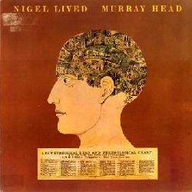
Debut album. Produced by Joe Wissert.

 1972 Pacing On The Station (M.Head)
1972 Big City (M.Head)
 1972 Bed & Breakfast (M.Head)
1972 The Party (M.Head)
1972 Ruthie (M.Head)
1972 City Scurry (M.Head)
 1972 When You Wake Up In The Morning (M.Head)
1972 Why Do We Have To Hurt Our Heads (M.Head)
 1972 Pity The Poor Consumer (M.Head)
 1972 Dole (M.Head)
 1972 Nigel, Nigel (M.Head)
 1972 Miss Illusion (M.Head)
 1972 Religion (M.Head)
Borrowing the melody from She Was Perfection
 1972 Junk (M.Head)

1974 Shirley’s World
Various Artists
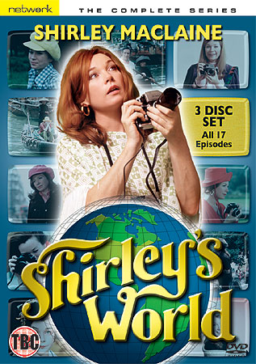

1974 Heads I Win, Tails You Lose (Unknown)
Very loose cover of the Beach Boys’ 1962 recording?.
1974 Heads I Win, Tails You Lose (Reprise) (Unknown)

1975 Raindog
Various Artists
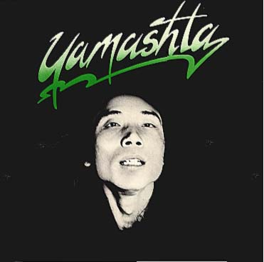
With Stomu Yamashta.

 1975 Dunes (S.Yamashta)
 1975 Rainsong (S.Yamashta)
1975 The Monks Song (S.Yamashta)

1975 Say It Ain't So (LP)
Solo
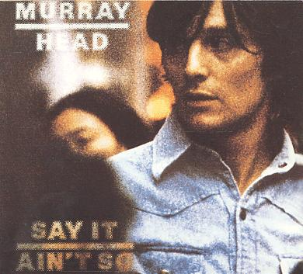

2nd solo album. Produced by Paul Samwell-Smith.

 1975 Say It Ain't So Joe (M.Head)
 1975 Boy On The Bridge (M.Head)
1975 Boats Away (M.Head)
 1975 When I'm Yours (M.Head)
 1975 Someone's Rocking My Dreamboat (L.Rene-E.Scott-O.Rene)
 1975 She's Such A Drag (M.Head)
 1975 Never Even Thought (M.Head)
1975 Silence Is A Strong Reply (M.Head-B.Weston)
1975 Don't Forget Him Now (M.Head)
1975 You're So Tasty (M.Head)

1975 Say It Ain't So Joe / Don't Have To
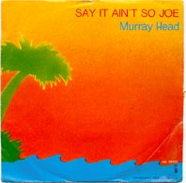
Solo

7" single. Non-album B-Side.

1975 Say It Ain't So Joe (M.Head)
1975 Don't Have To (D.Ash)
B-Side.

1978 Dear Anyone
Various Artists
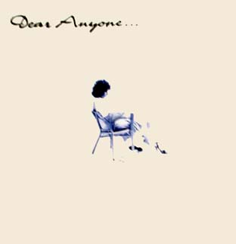

Soundtrack to show of same name. The premiere wasn't until 1983.

 1978 One-Sided Love (M.Head)

1978 Mademoiselle / Woman, I Love You
Solo

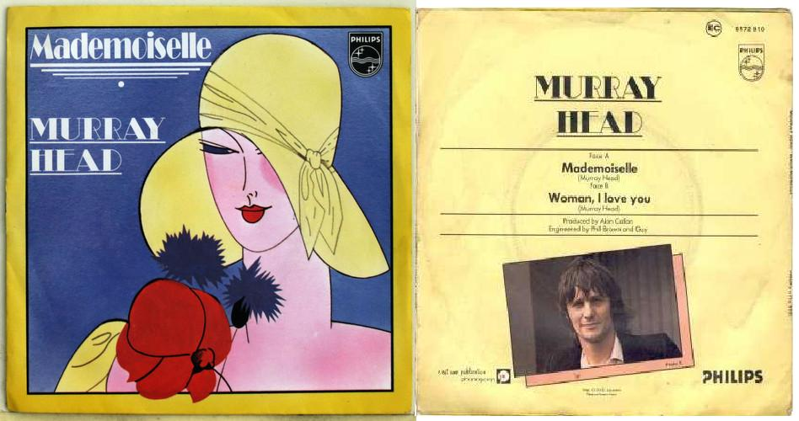

7" Single. Different to the version on Between Us. Non-album B-Side.

1978 Mademoiselle [Single] (M.Head)
 1978 Woman, I Love You (M.Head)
B-Side.

1979 Between Us (LP)
Solo

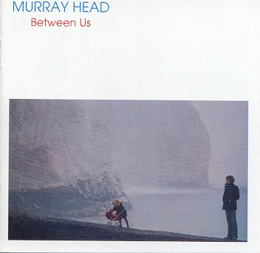
3rd solo album. Produced by Rupert Hine.

 1979 Los Angeles (M.Head)
 1979 How Many Ways (M.Head)
1979 Rubbernecker (M.Head)
 1979 Mademoiselle (M.Head)
 1979 Sorry, I Love You (M.Head)
 1979 Countryman (M.Head)
1979 It's So Hard Singing The Blues (M.Head)
 1979 Good Old Days (M.Head)
 1979 Lady I Could Serve You Well (M.Head)
1979 Bye Bye Bye (M.Head)

1980 Cocktail Molotov
Various Artists
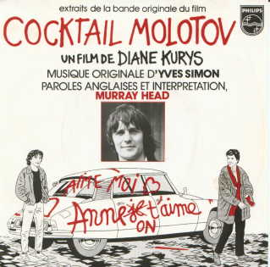

Soundtrack to film of same name by Diane Kurys. Music by Yves Simon.

 1980 Cocktail Molotov (M.Head-Y.Simon)
1980 Dearest Anne (M.Head-Y.Simon)
 1980 Dearest Anne [Reprise] (M.Head-Y.Simon)

1980 Voices (LP)
Solo
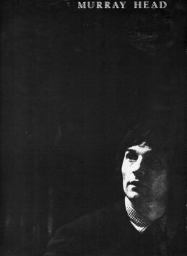

4th solo album. Produced by Paul Samwell-Smith.

 1980 Last Days Of An Empire (M.Head)
Also known as Last Daze Of An Empire.
1980 Affair Across A Crowded Room (M.Head)
1980 Hey Lady (M.Head)
 1980 On Your Own Again (M.Head)
1980 Time On The Line (M.Head)
 1980 Chance Encounter (M.Head)
 1980 Children Only Play (Do You Remember?) (M.Head)
 1980 Old Soho (M.Head)
1980 A Tree (M.Head)
 1980 Going Home (M.Head)

1981 How Many Ways
Solo
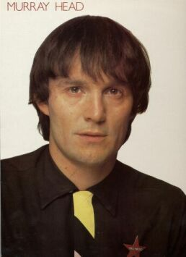

Similar to Voices, but replacing A Tree and Hey Lady with new versions of How Many
Ways and Los Angeles. Produced by Paul Samwell-Smith.

1980 Old Soho (M.Head)
1981 Los Angeles [New Version] (M.Head)
1981 How Many Ways [New Version] (M.Head)
1980 On Your Own Again (M.Head)
1980 Time On The Line (M.Head)
1980 Chance Encounter (M.Head)
1980 Affair Across A Crowded Room (M.Head)
1980 Last Days Of An Empire (M.Head)
1980 Children Only Play (Do You Remember?) (M.Head)
1980 Going Home (M.Head)

1981 Old Soho
Solo
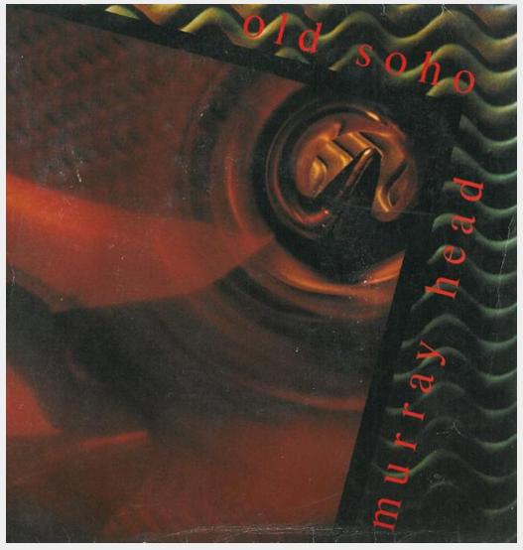

A different version to the LP. The sleeve gives A Tree as the B-Side, but in fact it was the LP version of Old Soho.
1981 Old Soho [Single] (M.Head)
A different version to the one on Voices and How Many Ways.
1980 Old Soho (M.Head)

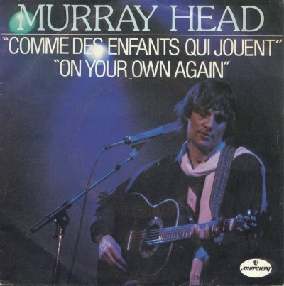
1981 Comme Des Enfants Qui Jouent / On Your Own Again
Solo

7" Single. Non-album A-Side.

1981 Comme Des Enfants Qui Jouent (M.Head-L.Plamondon)
French lyrics set to the melody from Children Only Play.
1980 On Your Own Again (M.Head)

1981 Find The Crowd (LP)
Solo

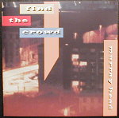
Live recordings from 1981 tour.

 1981 Los Angeles [Live] (M.Head)
1981 Losing You [Live] (J.Lennon)
1981 How Many Ways [Live] (M.Head)
1981 Old Soho [Live] (M.Head)
1981 Children Only Play (Do You Remember?) [Live] (M.Head)
1981 Last Days Of An Empire [Live] (M.Head)
1981 Countryman [Live] (M.Head)
1981 Never Even Thought [Live] (M.Head)
1981 Say It Ain't So Joe [Live] (M.Head)
 1981 Pity The Poor Consumer [Live] (M.Head)

1982 Shade (LP)
Solo
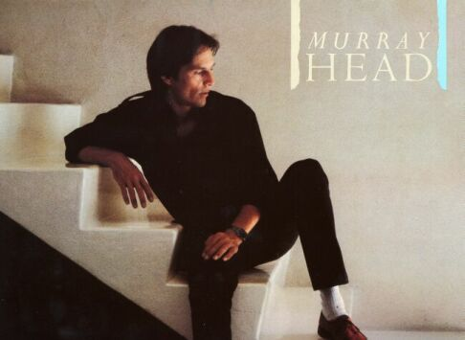
Produced by Steve Nye.

1982 Peace Of Mind (M.Head)
1982 Corporation Corridors (M.Head)
 1982 All We Can Do Is Hold On (J.Sample)
1982 Not Your Problem (M.Head)
1982 Joey's On Fire (M.Head-P.Veitch)
1982 Maman (M.Head)
1982 Grace (M.Head)
1982 Dragonfly (M.Head)
1982 Shades Of The Prison House (M.Head)

1982 Pour Cent Briques T'as Plus Rien
Various Artists
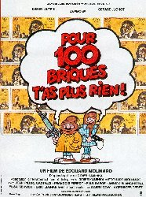

Directed by Edouard Molinaro. Music by Murray Head, Peter Veitch and Geoff
Richardson.

1982 With Or Without Me (M.Head)
1982 Sam's Sacrifice (G.Richardson-P.Veitch)
Instrumental (background music)
1982 The Chase (G.Richardson-P.Veitch)
Instrumental (background sound effects).
1982 No Mystery (M.Head)
1982 No Mystery [Reprise] (M.Head)

1982 No Mystery / With Or Without Me
Solo

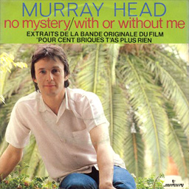

7" Single. Highlights from Pour Cents Briques T’as Plus Rien.

1982 No Mystery [Single Version] (M.Head)
 1982 With Or Without Me [Single Version] (M.Head)

1984 Restless (LP)
Solo

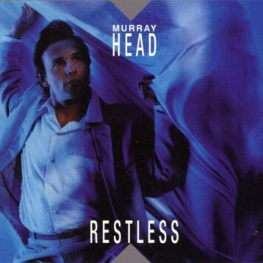
Produced by Steve Nye and Murray Head.

 1984 When You're In Love (M.Head-P.Veitch-P.Palmer)
1984 Catching Eddie At It (P.Veitch-P.Palmer)
1984 Modern Boy (M.Head)
1984 Peril In Venice (M.Head-P.Veitch-P.Palmer)
1984 Salvation (Missionary Madness) (M.Head)
1984 Mario (M.Head)
1984 African Tourists (M.Head)
 1984 Hold Me (M.Head)
1984 I Don't Care (M.Head)
1984 Maybe Tomorrow (M.Head)

1984 Chess (LP)
Various Artists
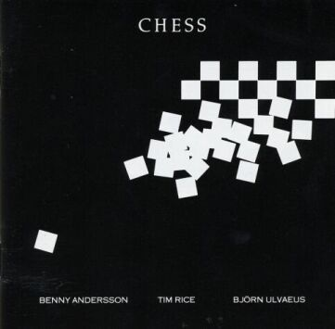

Soundtrack to show of same name. Produced by Tim Rice, Benny Andersson and Björn
Ulvaeus.

1984 Merano (B.Andersson-T.Rice-B.Ulvaeus)
1984 The American And Florence / Nobody's Side (B.Andersson-T.Rice-B.Ulvaeus)
With Elaine Paige
1984 Florence Quits (B.Andersson-T.Rice-B.Ulvaeus)
With Elaine Paige
 1984 Bangkok / One Night In Bangkok (B.Andersson-T.Rice-B.Ulvaeus)
1984 The Deal (No Deal) (B.Andersson-T.Rice-B.Ulvaeus)
With Tommy Korberg
 1984 Pity The Child (B.Andersson-T.Rice-B.Ulvaeus)
1984 Endgame (B.Andersson-T.Rice-B.Ulvaeus)
With Elaine Paige, Tommy Korberg, Denis Quilley and Barbara Dickson

1984 One Night In Bangkok EP
Various Artists

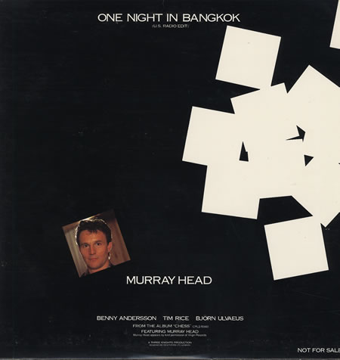

12” single.

1984 Bangkok / One Night In Bangkok [Extended Mix] (B.Andersson-T.Rice-B.Ulvaeus)
1984 Merano (B.Andersson-T.Rice-B.Ulvaeus)

1985 Picking Up The Pieces EP
Solo
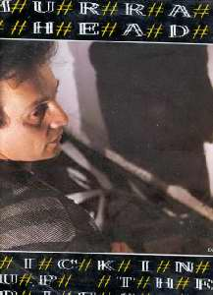
Produced by Steve Hillage. Non-album Track 1.

1985 Picking Up The Pieces [Extended Mix] (C.Difford-G.Tillbrook)
1985 Picking Up The Pieces [Radio Edit] (C.Difford-G.Tillbrook)
1984 Maybe Tomorrow (M.Head)

1985 The Flying Devils
Various Artists
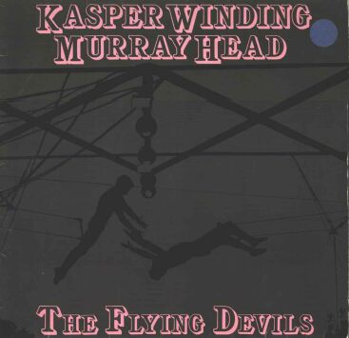

Soundtrack to film of same name. With Kasper Winding.

1985 Please Don't Leave Me Now (M.Head-K.Winding)
1985 It's A Dream (M.Head-K.Winding)
1985 Take This Heavy Load (M.Head-K.Winding)

1985 Please Don't Leave Me Now / Lazlo
Solo
7" Single. Different to the version on The Flying Devils. Non-album A-Side.

 1985 Please Don't Leave Me Now [Single] (M.Head-K.Winding)
1985 Lazlo (M.Head-K.Winding)
B-Side. An instrumental.

1985 Performance
Various Artists
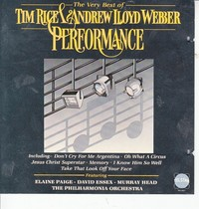

Collection of alternative and cover versions of famous show songs - Bangkok,
Superstar, etc. Also known as The Very Best Of Tim Rice & Andrew Lloyd Webber.

1985 Running Back For More (T.Rice-S.Oliver)
Cover version of a song from Blondel written by Tim Rice and Stephen Oliver.
Originally recorded by Elaine Page in 1983.
1985 Superstar [New Version] (T.Rice-A.Lloyd Webber)

1986 Time The Musical
Various Artists
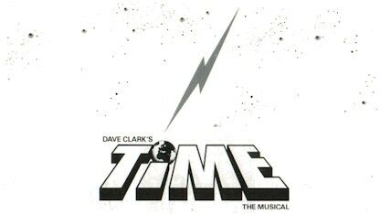

Soundtrack to show of same name. By Dave Clark.

1986 We're The UFO (D.Clark-J.Daniels-D.Soames)

1986 Some People / African Tourists
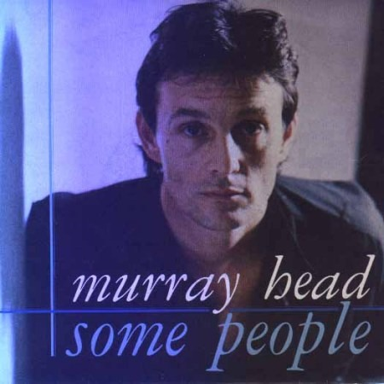
Solo

12" Single. Non-album A-Side - eventually released as a bonus track on the Remastered Sooner Or Later CD (2001).

1986 Some People (B.Some)
1984 African Tourists (M.Head)

1987 Sooner Or Later (LP)
Solo
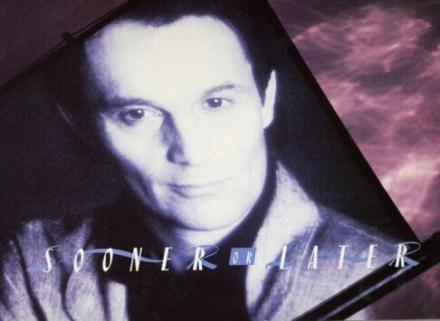

Includes Love List - which was dropped on the Remastered CD (2001). Recorded in 1986
but not released until 1987. Produced by Steve Hillage.

1986 You Are (M.Head)
1986 With A Passion (M.Mancina-B.Hovis)
1986 Love List (M.Head)
Not available on the remastered CD
1986 Lana Turner (OMD-B.Jenkins-I.Trimmer)
1986 Love Is Believing (M.Head)
 1986 In The Heart Of You (P.Veitch)
1986 Paper Thin (G.Richardson)
1986 Fear And Ambition (M.Head)
1986 Wanderer (M.Head)

1988 À Gauche en Sortant de l'Ascenseur
Various Artists
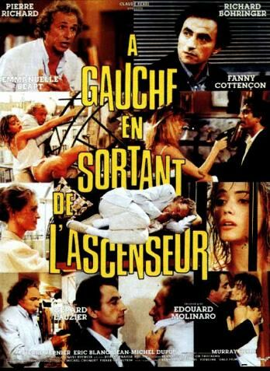

Soundtrack to film of same name by Edward Molinaro. Produced by Peter Veitch and
Murray Head.

1988 Affair Across A Crowded Room [New Version] (M.Head)
With Ann Turner
 1988 Still In Love With You (M.Head)
 1988 New Laws Of Love (M.Head)
1988 All The Way (M.Head-P.Veitch-P.Palmer)

1989 Un Été d'Orages
Various Artists

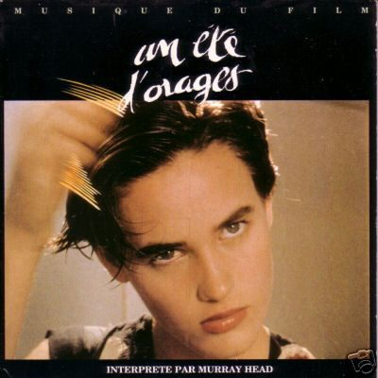

Soundtrack to film of same name by Charlotte Brandstrom.

1989 Darling 1944 (Un Été d’Orages) (M.Head-C.Cohen)
French lyrics set to the melody from Time On The Line.
Originally entitled Un Été d'Orages, later renamed Darling 1944.
1989 Le Temps S’en Fout (M.Head)
Instrumental. B-Side filler, credited to Murray Head, though this is highly dubious.

1990 Centrepoint
Various Artists
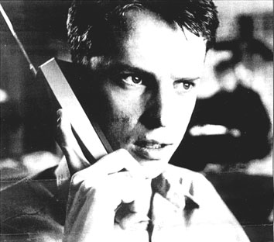

6-part TV mystery series.

1990 Won't Get Fooled Again (P.Townshend)
1990 No Social Democrat (Unknown)
 1990 Won't Get Fooled Again [Outro] (P.Townshend)

1990 Say It Ain't So (Remastered)
Solo

Remastered reissue of the original Say It Ain't So LP (1975).
Identical cover and tracklist.

1990 Watching Ourselves Go By
Solo

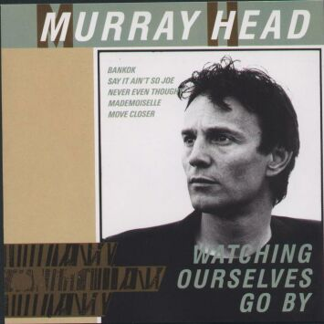

Greatest hits compilation.

1990 Move Closer (P.Nelson)
1982 Corporation Corridors (M.Head)
1982 Joey's On Fire (M.Head-P.Veitch)
1982 Maman (M.Head)
1979 Rubbernecker (M.Head)
1984 Bangkok / One Night In Bangkok (B.Andersson-T.Rice-B.Ulvaeus)
1981 Los Angeles [New Version] (M.Head)
1975 Say It Ain't So Joe (M.Head)
1981 How Many Ways [New Version] (M.Head)
1980 Last Days Of An Empire (M.Head)
1975 Never Even Thought (M.Head)
1979 Mademoiselle (M.Head)
1981 Los Angeles [Live] (M.Head)

1992 Wave (LP)
Solo
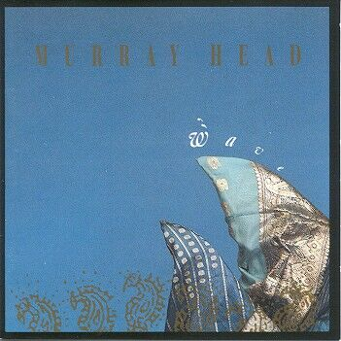

Later to be reissued on CD as Innocence (Remastered). Rather different to the
Original Innocence (LP). Produced by P.Whittaker, M.Head, S.Fletcher, B.Kelleher
and S.Ferrara.

 1992 All Eyes Are On The West (M.Head)
1992 Feel No Shame (M.Head)
This song was replaced by Move Closer on the reissue of Wave (LP) as
Innocence (Remastered)
1992 Ocean (M.Head)
1992 Innocence (M.Head-P.Whittaker)
 1992 Just Enough (M.Head-S.Fletcher)
1992 Caprice (M.Head-S.Fletcher)
1992 Nothing To Lose (M.Head-S.Fletcher-P.Whittaker)
1992 Little Bit Of Loving (M.Head)
1992 Fear Of Life (M.Head)
 1992 Make It Easy (M.Head)

1993 Innocence (LP)
Solo
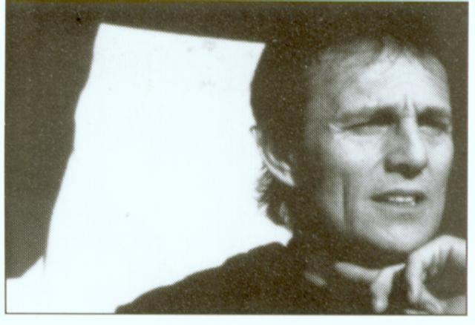
Not to be confused with the CD Innocence (Remastered), which is a virtual reissue of Wave (1992). Produced by P.Whittaker, M.Head, S.Fletcher, B.Kelleher, S.Ferrara and J.Millaire.

1992 Nothing To Lose (M.Head-S.Fletcher-P.Whittaker)
1990 Move Closer (P.Nelson)
This song replaced Feel No Shame on the reissue of Wave (LP) as
Innocence (Remastered)
1992 Comme Des Enfants Qui Jouent [New Version] (M.Head-L.Plamondon)
French lyrics set to the melody from Children Only Play.
1992 All Eyes Are On The West (M.Head)
 1992 Le Temps Passe (B.Lavilliers)
 1993 When You're In Love [New Version] (M.Head-P.Veitch-P.Palmer)
1992 Ocean (M.Head)
1992 Innocence (M.Head-P.Whittaker)
1993 Little Bit Of Loving [New Edit] (M.Head)
1993 Une Femme, Un Homme (M.Head-L.Plamandon)
With Marie Carmen. French lyrics set to the melody from You Are.
1992 Make It Easy (M.Head)

1993 Find The Crowd (Remastered)
Solo
Remastered reissue of the original Find The Crowd LP (1981).
Identical cover and track list.

1994 Say It Ain't So Joe EP
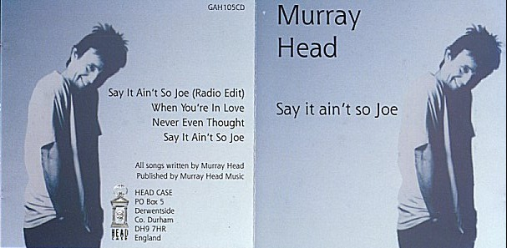
Solo

New versions of Say It Ain't So Joe, When You're In Love and Never Even Thought. Non-album Track 1.

1994 Say It Ain't So Joe [New Version - Radio Edit] (M.Head)
A radio-friendly (shortened) version of the 1993 recording.
1993 When You're In Love [New Version] (M.Head-P.Veitch-P.Palmer)
 1993 Never Even Thought [New Version] (M.Head)
 1993 Say It Ain't So Joe [New Version] (M.Head)

1995 Pipe Dreams
Solo
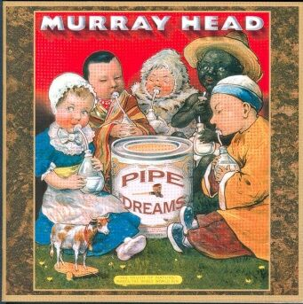

Produced by Ian Maidman and Murray Head.

1995 Who Loves You (B.Gaudio-J.Parker)
1995 Only A Pipe Dream (M.Head-I.Maidman)
1995 Prison Wall Blues (G.Cannon)
1995 Si Tu Veux Être Un Homme (M.Head-I.Maidman-R.Kipling-A.Maurois)
 1995 Shadows Of The Truth (M.Head)
1995 Dancing Flamenco Alone (M.Head-I.Maidman)
 1995 When They Found Eldorado (M.Head-I.Maidman)
1995 Is That All There Is (J.Leiber-M.Stoller)
1995 Over The Hill (M.Head)
1995 Fair And Tender Ladies (Trad.)
1995 Hesitation Blues (G.Davis)
1995 India Song (M.Duras-C.D'alessio)
1995 Sedentary Nomad (M.Head)
1995 Ça N'Était Que Ça (Leiber-Stoller-C.Cochaux)
French version of Is That All There Is

1996 Pipe Dreams EP
Solo
Different versions to the one on the Pipe Dreams album.
Non-album Tracks 1 and 2.

1996 Only A Pipe Dream [Remix] (M.Head-I.Maidman)
 1996 Only A Pipe Dream [Remix - Radio Edit] (M.Head-I.Maidman)
A shortened (radio) version of the Only A Pipe Dream Remix

1995 When You're In Love [FR]
Solo
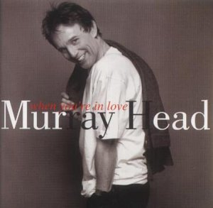

Greatest hits compilation (French release). Later to be re-released as Greatest Hits (2001).

1993 Say It Ain't So Joe [New Version] (M.Head)
1993 You Are [New Version] (M.Head)
1993 Never Even Thought [New Version] (M.Head)
1993 When You're In Love [New Version] (M.Head-P.Veitch-P.Palmer)
1982 No Mystery [Single Version] (M.Head)
1980 Dearest Anne [Reprise] (M.Head-Y.Simon)
1993 Maman [New Version] (M.Head)
1989 Darling 1944 (Un Été d’Orages) (M.Head-C.Cohen)
1982 With Or Without Me [Single Version] (M.Head)
1988 Affair Across A Crowded Room [New Version] (M.Head)
With Ann Turner
1985 Picking Up The Pieces [Radio Edit] (C.Difford-G.Tillbrook)
1981 Los Angeles [New Version] (M.Head)
1980 Cocktail Molotov (M.Head-Y.Simon)
1988 Still In Love With You (M.Head)
1988 All The Way (M.Head-P.Veitch-P.Palmer)
1992 Comme Des Enfants Qui Jouent [New Version] (M.Head-L.Plamondon)
French lyrics set to the melody from Children Only Play.
1978 Mademoiselle [Single] (M.Head)
1992 Le Temps Passe (B.Lavilliers)
1994 Bangkok / One Night In Bangkok [Alternative New Edit] (B.Andersson-T.Rice-B.Ulvaeus)

1996 When You're In Love [CA]
Solo

Greatest hits compilation (Canadian release). Rather different to the French release.

1993 Say It Ain't So Joe [New Version] (M.Head)
1992 Comme Des Enfants Qui Jouent [New Version] (M.Head-L.Plamondon)
French lyrics set to the melody from Children Only Play.
1993 Never Even Thought [New Version] (M.Head)
1993 When You're In Love [New Version] (M.Head-P.Veitch-P.Palmer)
1982 No Mystery [Single Version] (M.Head)
1993 Une Femme, Un Homme (M.Head-L.Plamandon)
1980 Dearest Anne [Reprise] (M.Head-Y.Simon)
1993 Maman [New Version] (M.Head)
1989 Darling 1944 (Un Été d’Orages) (M.Head-C.Cohen)
1982 With Or Without Me [Single Version] (M.Head)
1981 Los Angeles [New Version] (M.Head)
1980 Cocktail Molotov (M.Head-Y.Simon)
1978 Mademoiselle [Single] (M.Head)
1988 All The Way (M.Head-P.Veitch-P.Palmer)
1996 Bangkok / One Night In Bangkok [New Version] (B.Andersson-T.Rice-B.Ulvaeus)
1995 L'Impossible Amant (M.Head)
French lyrics set to the melody from Dancing Flamenco Alone.

1996 Les Enfants du Futur
Various Artists
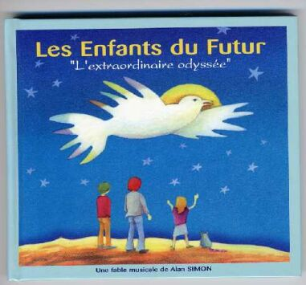

Soundtrack from the show of the same name. By Alan Simon.

1996 C'est Fou (A.Simon)
With Mathilda May. Backing vocals only.
 1996 SOS World (A.Simon)

1996 Jesus Christ Superstar (Remastered)
Various Artists
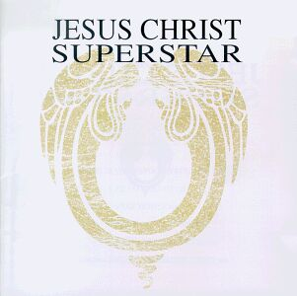

Remastered reissue of the original Jesus Christ Superstar LP (1970).
Different cover; identical track list.

1996 Between Us (Remastered)
Solo
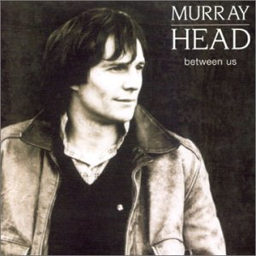
Remastered reissue of the original Between Us (1979). Also issued as Gold. Includes bonus tracks No Mystery and Say It Ain't So Joe. Produced by Rupert Hine.

1979 Los Angeles (M.Head)
1979 How Many Ways (M.Head)
1979 Rubbernecker (M.Head)
1979 Mademoiselle (M.Head)
1979 Sorry, I Love You (M.Head)
1979 Countryman (M.Head)
1979 It's So Hard Singing The Blues (M.Head)
1979 Good Old Days (M.Head)
1979 Lady I Could Serve You Well (M.Head)
1982 No Mystery [Single Version] (M.Head)
1993 Say It Ain't So Joe [New Version] (M.Head)
1979 Bye Bye Bye (M.Head)

1996 Voices (Remastered)
Solo
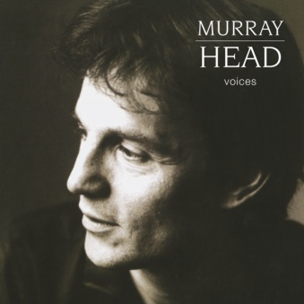

Combining tracks from Voices (LP) and How Many Ways. Includes bonus track Never
Even Thought. Produced by Paul Samwell-Smith.

1980 Last Days Of An Empire (M.Head)
1980 Affair Across A Crowded Room (M.Head)
1980 Hey Lady (M.Head)
1980 On Your Own Again (M.Head)
1980 Time On The Line (M.Head)
1980 Chance Encounter (M.Head)
1980 Children Only Play (Do You Remember?) (M.Head)
1980 Old Soho (M.Head)
1980 A Tree (M.Head)
1980 Going Home (M.Head)
1981 Los Angeles [New Version] (M.Head)
1981 How Many Ways [New Version] (M.Head)
1993 Never Even Thought [New Version] (M.Head)

1996 Chess (Remastered)
Various Artists

Remastered reissue of the original Chess LP (1984). Identical cover and track list.

1998 Galo Negro
Various Artists
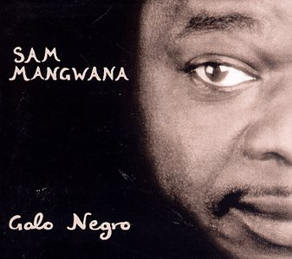

By Sam Mangwana.

1998 Manjani (S.Mangwana)
With Sam Mangwana.

1998 Ils Chantent Goldman
Various Artists
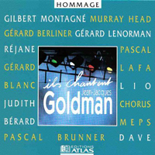

Various artists. Tribute album.

1998 Là-Bas (J-J.Goldman)
With Lio

1998 Ils Chantent Sardou
Various Artists
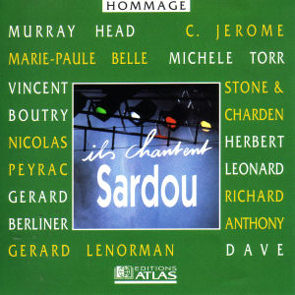

Various artists. Tribute album.

1998 Chanteur de Jazz (M.Sardou-J-L.Dabadie-J.Revaux-J-P.Bourtayre)

1998 Ils Chantent Balavoine
Various Artists
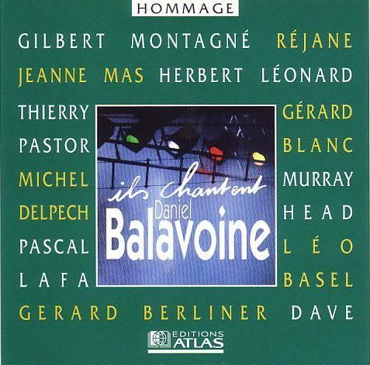

Various artists. Tribute album.

 1998 L'Aziza (D.Balavoine)

1998 Ils Chantent Cabrel
Various Artists
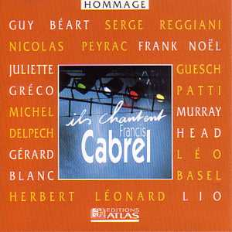

Various artists. Tribute album.

1998 La Cabane du Pêcheur (F.Cabrel)

1998 Ils Chantent Polnareff
Various Artists
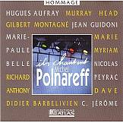

Various artists. Tribute album.

1998 Tout, Tout Pour Ma Chérie (M.Polnareff)

1998 Básico
Various Artists

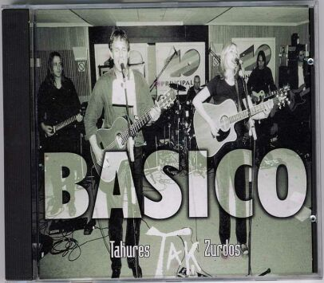
Bonus live CD with TAK by Tahures Zurdos [1997].

 1998 Dime Que No (M.Head-A.Cifuentes)
With Tahures Zurdos. Spanish version of Say It Ain't So Joe.
1998 Say It Ain't So Joe [Tahures Zurdos] (M.Head)
With Tahures Zurdos

2000 Terra Saabi
Various Artists
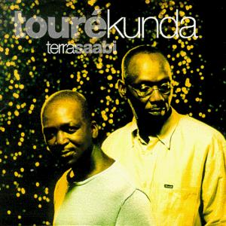

By Touré Kunda.

2000 SDF / Homeless (I.Touré-S.Touré)
With Touré Kunda.

2000 Innocence (Remastered)
Solo
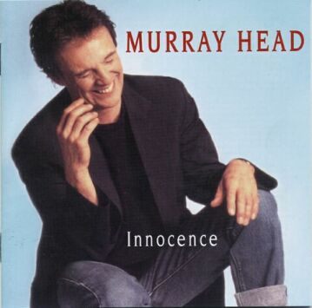

Originally released as Wave (1992), except Move Closer (from the *original* Innocence) replaces Feel No Shame. Produced by P.Whittaker, M.Head, S.Fletcher, B.Kelleher and S.Ferrara

1992 Nothing To Lose (M.Head-S.Fletcher-P.Whittaker)
1992 All Eyes Are On The West (M.Head)
1990 Move Closer (P.Nelson)
1992 Ocean (M.Head)
1992 Innocence (M.Head-P.Whittaker)
1992 Just Enough (M.Head-S.Fletcher)
1992 Caprice (M.Head-S.Fletcher)
1993 Little Bit Of Loving [New Edit] (M.Head)
1992 Fear Of Life (M.Head)
1992 Make It Easy (M.Head)

2001 Nigel Lived (Remastered)
Solo
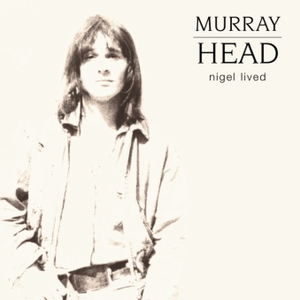

Remastered reissue of the original Nigel Lived LP (1972).
Different cover; identical track list.

2001 Shade (Remastered)
Solo
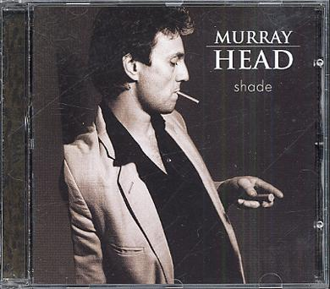
Remastered reissue of the original Shade (1982). Includes bonus tracks Mario, All The Way and When You're In Love. Produced by Steve Nye.

1982 Peace Of Mind (M.Head)
1982 Corporation Corridors (M.Head)
1982 All We Can Do Is Hold On (J.Sample)
1982 Not Your Problem (M.Head)
1982 Joey's On Fire (M.Head-P.Veitch)
1982 Maman (M.Head)
1982 Grace (M.Head)
1982 Dragonfly (M.Head)
1984 Mario (M.Head)
1988 All The Way (M.Head-P.Veitch-P.Palmer)
1993 When You're In Love [New Version] (M.Head-P.Veitch-P.Palmer)
1982 Shades Of The Prison House (M.Head)

2001 Restless (Remastered)
Solo

Remastered reissue of the original Restless LP (1984). Identical cover and track list.

2001 Sooner Or Later (Remastered)
Solo
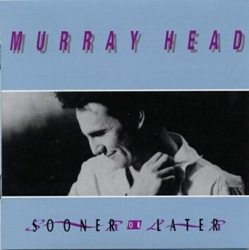

Reissue of Sooner Or Later (1987) without Love List. Includes bonus tracks Picking Up
The Pieces and Some People. Produced by Steve Hillage.

1986 You Are (M.Head)
1986 Lana Turner (OMD-B.Jenkins-I.Trimmer)
1986 With A Passion (M.Mancina-B.Hovis)
1986 Love Is Believing (M.Head)
1986 In The Heart Of You (P.Veitch)
1986 Paper Thin (G.Richardson)
1986 Fear And Ambition (M.Head)
1986 Wanderer (M.Head)
1985 Picking Up The Pieces [Radio Edit] (C.Difford-G.Tillbrook)
1986 Some People (B.Some)

2001 Greatest Hits
Solo
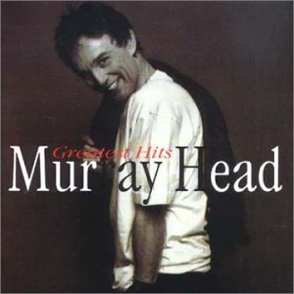

Reissue of When You're In Love [FR] compilation (1995), but replacing the original One Night In Bangkok (1984) with a new version.

1993 Say It Ain't So Joe [New Version] (M.Head)
1993 You Are [New Version] (M.Head)
1993 Never Even Thought [New Version] (M.Head)
1993 When You're In Love [New Version] (M.Head-P.Veitch-P.Palmer)
1982 No Mystery [Single Version] (M.Head)
1980 Dearest Anne [Reprise] (M.Head-Y.Simon)
1993 Maman [New Version] (M.Head)
1989 Darling 1944 (Un Été d’Orages) (M.Head-C.Cohen)
1982 With Or Without Me [Single Version] (M.Head)
1988 Affair Across A Crowded Room [New Version] (M.Head)
With Ann Turner
1985 Picking Up The Pieces [Radio Edit] (C.Difford-G.Tillbrook)
1981 Los Angeles [New Version] (M.Head)
1980 Cocktail Molotov (M.Head-Y.Simon)
1988 Still In Love With You (M.Head)
1988 All The Way (M.Head-P.Veitch-P.Palmer)
1992 Comme Des Enfants Qui Jouent [New Version] (M.Head-L.Plamondon)
French lyrics set to the melody from Children Only Play.
1978 Mademoiselle [Single] (M.Head)
1992 Le Temps Passe (B.Lavilliers)
1996 Bangkok / One Night In Bangkok [New Version] (B.Andersson-T.Rice-B.Ulvaeus)

2002 Autour de la Guitare
Various Artists
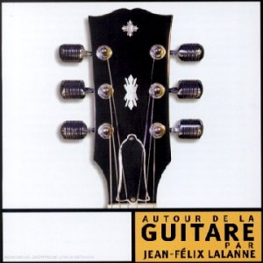
Various artists. Compiled and produced by Jean-Félix Lalanne.

2002 Say It Ain't So Joe [Michael Jones] (M.Head)
With Michael Jones.

2002 Cindy
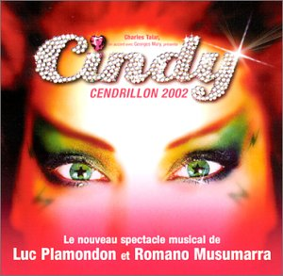
Various Artists

Soundtrack to show of same name. Produced by Luc Plamandon and Romano Musumarra.

 2002 Un Homme Qui Passe (L.Plamandon-R. Musumarra)
With Lââm
2002 La Légende de Rose Latulipe (L.Plamandon-R. Musumarra)
2002 Celui Que J'Aimerai (L.Plamandon-R. Musumarra)
With Lââm
2002 Envoie-Moi Vers Les Étoiles (L.Plamandon-R. Musumarra)
With Frank Sherbourne, Judith Bérard, Lââm, Carine, Assia, Patsy Gallant, Jay, Patrice Blouin and Kristel Adams

2002 Passion
Solo
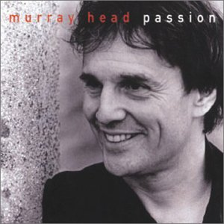

New compilation of old material including new edits and remixes, etc.

1993 Say It Ain't So Joe [New Version] (M.Head)
2002 Never Even Thought [New Edit] (M.Head)
Shortened remix of the new version (1993).
1979 Mademoiselle (M.Head)
2002 Dearest Anne [Reprise, New Edit] (M.Head-Y.Simon)
Shortened remix of the original version (1980).
1995 Hesitation Blues (G.Davis)
1981 Losing You [Live] (J.Lennon)
1992 Comme Des Enfants Qui Jouent [New Version] (M.Head-L.Plamondon)
French lyrics set to the melody from Children Only Play.
1993 Little Bit Of Loving [New Edit] (M.Head)
2002 Affair Across A Crowded Room [New Edit] (M.Head)
Shortened remix of the original version (1980).
2002 Sorry, I Love You [New Edit] (M.Head)
Shortened remix of the original version (1979).
1992 Make It Easy (M.Head)
1975 When I'm Yours (M.Head)
1972 Ruthie (M.Head)
1982 Grace (M.Head)

2002 Cindy Live
Various Artists
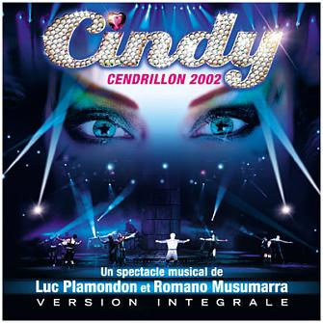

Recorded in Paris.

 2002 La Légende de Rose Latulipe [Paris] (L.Plamandon-R. Musumarra)
2002 Un Homme Qui Passe [Paris] (L.Plamandon-R. Musumarra)
Part 1/4 of Un Homme Qui Passe. With Lââm.
2002 Un Homme Qui Passe [Reprise, Paris] (L.Plamandon-R. Musumarra)
Part 2/4 of Un Homme Qui Passe. With Patsy Gallant and Kristel Adams.
2002 Avant d'Aller Plus Loin (L.Plamandon-R. Musumarra)
With Patsy Gallant.
2002 Un Homme Qui Passe [Re-Reprise, Paris] (L.Plamandon-R. Musumarra)
Part 3/4 of Un Homme Qui Passe. With Lââm, Patsy Gallant and Kristel Adams.
2002 Celui Que J'Aimerai [Paris] (L.Plamandon-R. Musumarra)
With Lââm.
2002 Je T'Attendrai Sous Le Grand Chêne (L.Plamandon-R. Musumarra)
Part 4/4 of Un Homme Qui Passe (including a change of title). With Lââm.
2002 Aime-La (L.Plamandon-R. Musumarra)
With Frank Sherbourne, Jay and Patrice Blouin.
2002 Envoie-Moi Vers Les Étoiles [Reprise, Paris] (L.Plamandon-R. Musumarra)
With Frank Sherbourne, Judith Bérard, Lââm, Carine, Assia,
Patsy Gallant, Jay, Patrice Blouin, Jean Leduc and Kristel Adams.

2003 Sereine
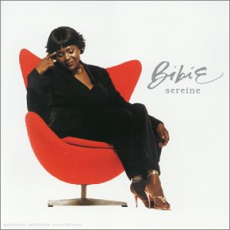
Various Artists

By Bibie.

2003 La Route à L'Envers (M.Head-M.Deva)
With Bibie. French lyrics based on Still In Love With You set to the melody from Never
Even Thought.

2005 Emotions (My Favourite Songs)
Solo

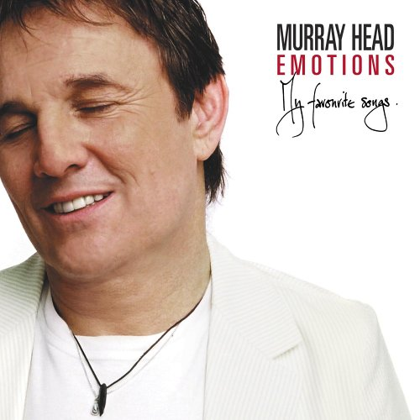
Another greatest hits compilation, including new versions of Never Even Thought, Fair
And Tender Ladies and Make It Easy, plus a cover of Will You Still Love Me Tomorrow?

2004 Never Even Thought [Manpower] (M.Head)
Another new version (2004).
1993 Say It Ain't So Joe [New Version] (M.Head)
2005 Make It Easy [Original Duet] (M.Head)
New version with Sophie Head
1982 Corporation Corridors (M.Head)
1993 You Are [New Version] (M.Head)
1978 Mademoiselle [Single] (M.Head)
1982 Maman (M.Head)
1981 Losing You [Live] (J.Lennon)
1988 Bangkok / One Night In Bangkok [New Edit] (B.Andersson-T.Rice-B.Ulvaeus)
Abridged radio-friendly version of the original 1984 Chess recording.
1992 Comme Des Enfants Qui Jouent [New Version] (M.Head-L.Plamondon)
French lyrics set to the melody from Children Only Play.
1975 When I'm Yours (M.Head)
1981 Los Angeles [New Version] (M.Head)
1995 Fair And Tender Ladies [New Version] (Trad.)
Frequently mistitled Fair And Tender *Maidens* and miscredited to *Murray Head*
(instead of *Ladies* and *Trad*)
2005 Will You Still Love Me Tomorrow? (C.King-G.Goffin)
Cover version of Carole King's classic hit.
1980 Last Days Of An Empire (M.Head)
 2004 Never Even Thought [Kalimba] (M.Head)
Yet another new version, originally a hidden track. Promoted to main version in the
2006 Canadian release of Emotions.

2006 Emotions [CA]
Solo

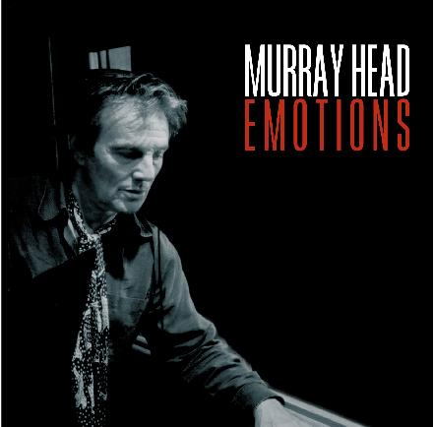

Canadian release, similar to original Emotions, adding two new versions of Make It Easy,
and replacing the Manpower version of Never Even Thought with the Kalimba version
(twice!).

2004 Never Even Thought [Kalimba] (M.Head)
Yet another new version, originally a hidden track. Promoted to main version in the
2006 Canadian release of Emotions.
1993 Say It Ain't So Joe [New Version] (M.Head)
 2006 Make It Easy [New Version] (M.Head)
A new upbeat version of Make It Easy. Duet with Sophie Head.
1982 Corporation Corridors (M.Head)
1993 You Are [New Version] (M.Head)
1978 Mademoiselle [Single] (M.Head)
1982 Maman (M.Head)
1981 Losing You [Live] (J.Lennon)
1988 Bangkok / One Night In Bangkok [New Edit] (B.Andersson-T.Rice-B.Ulvaeus)
Abridged radio-friendly version of the original 1984 Chess recording.
1992 Comme Des Enfants Qui Jouent [New Version] (M.Head-L.Plamondon)
French lyrics set to the melody from Children Only Play.
1975 When I'm Yours (M.Head)
1981 Los Angeles [New Version] (M.Head)
1995 Fair And Tender Ladies [New Version] (Trad.)
Frequently mistitled Fair And Tender *Maidens* and miscredited to *Murray Head*
(instead of *Ladies* and *Trad*)
2005 Will You Still Love Me Tomorrow? (C.King-G.Goffin)
Cover version of Carole King's classic hit.
1980 Last Days Of An Empire (M.Head)
2006 Make It Easy [French Version] (M.Head)
French version of Make It Easy. Duet with Sophie Head.
2004 Never Even Thought [Kalimba] (M.Head)
Identical to opening track, but hidden at the end of Make It Easy.

2006 Emotions [UK]
Solo

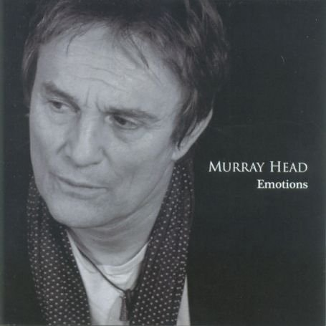

Different to its namesakes, this compilation is a cross between Emotions and Passion.
It includes a new version of Will You Still Love Me Tomorrow? - a duet with Tricia
Penrose.

2006 Will You Still Love Me Tomorrow? [New Version] (C.King-G.Goffin)
New version. Duet with Tricia Penrose. Released as an iTunes single.
2004 Never Even Thought [Manpower] (M.Head)
Another new version (2004).
1982 Corporation Corridors (M.Head)
1993 Say It Ain't So Joe [New Version] (M.Head)
2006 Make It Easy [New Version] (M.Head)
A new upbeat version of Make It Easy. Duet with Sophie Head.
1988 Bangkok / One Night In Bangkok [New Edit] (B.Andersson-T.Rice-B.Ulvaeus)
Abridged radio-friendly version of the original 1984 Chess recording.
1993 You Are [New Version] (M.Head)
1980 Cocktail Molotov (M.Head-Y.Simon)
1993 Little Bit Of Loving [New Edit] (M.Head)
1993 When You're In Love [New Version] (M.Head-P.Veitch-P.Palmer)
1981 Los Angeles [New Version] (M.Head)
1980 Last Days Of An Empire (M.Head)
1972 Ruthie (M.Head)
2002 Dearest Anne [Reprise, New Edit] (M.Head-Y.Simon)
Shortened remix of the original version (1980).
1995 Fair And Tender Ladies [New Version] (Trad.)
Frequently mistitled Fair And Tender *Maidens* and miscredited to *Murray Head*
(instead of *Ladies* and *Trad*)
2002 Affair Across A Crowded Room [New Edit] (M.Head)
Shortened remix of the original version (1980).
1970 Superstar (T.Rice-A.Lloyd Webber)

2006 Will You Still Love Me Tomorrow?
Various Artists

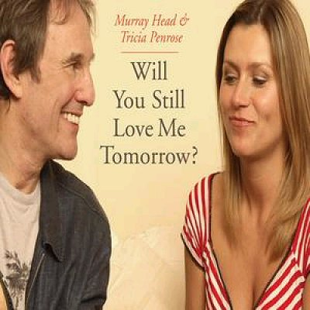

Duet with Tricia Penrose. Released as an iTunes single.

2006 Will You Still Love Me Tomorrow? [New Version] (C.King-G.Goffin)

2007 Tête à Tête
Solo
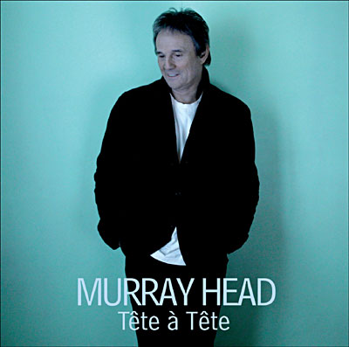

Recorded in 2006; released in 2007.

2006 Seras-Tu Là ? (M.Head-S.Aigrot)
Another new upbeat version of Make It Easy, with French lyrics.Duet with Sophie Head
 2006 Crystal Heart (M.Head-D.Ash)
2006 Tornado (M.Head)
 2006 Love Yourself (M.Head)
2006 Little One (M.Head-R.Paz)
2006 Loin Demain (F.Monnet)
2006 Who Do You Think You Are? (M.Head)
2006 I Believe In Stories (M.Head-D.Ash)
2006 That's Rich (M.Head)
 2006 So Strong (M.Feat)
2006 Lost My Baby Tonight (M.Head)
2006 This Face (M.Head)

2007 Rendez-Vous
Various Artists

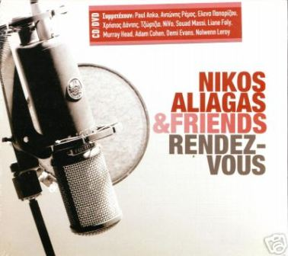

By Nikos Aliagas.

2007 You Do Something To Me (P.Weller)
Duet with Nikos Aliagas.

2008 Rien N’est Écrit
Solo

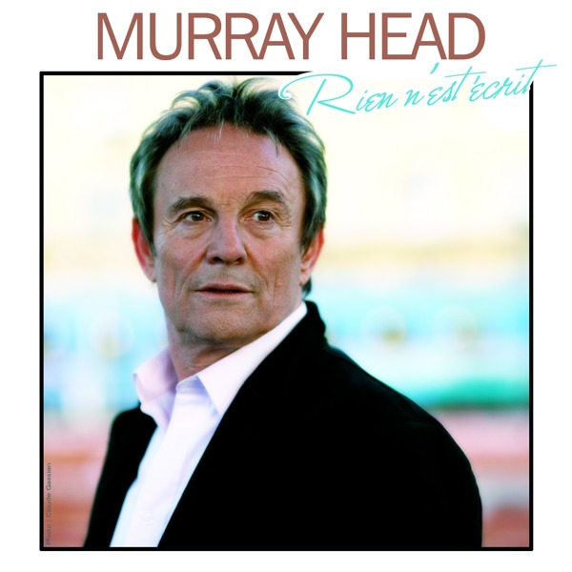

Theme tune from “Flics Toujours”. Originally released as an iTunes single.

2008 Rien N’est Écrit (K.Fahy-G.Luka)

2008 Rien N'est Écrit
Solo

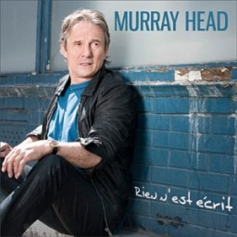

Murray's first "French album".

2008 Latitudes Pour Lassitude (J.Cotta-F.Eulry)
2008 Rien N'est Écrit (K.Fahy-G.Luka)
Theme tune from"Flics Toujours". Originally released as an iTunes single.
2008 Le Silence Est d'Or (G.Luka)
2008 Qui Sait (M.Head-K.Fahy-G.Luka)
Originally entitled "De l'Orient à l'Occident"
 2008 Now And Forever (M.Head-D.Esposito)
2008 India Song [New Edit] (M.Duras-C.d'Alessio)
Shortened remix of the original version (1995).
2008 Le Sud (N.Ferrer)
2008 Des Funambules (M-J.Zarb-G.Luka)
1995 L'Impossible Amant (M.Head-C.Cochaux-I.Maidman)
French lyrics set to the melody from Dancing Flamenco Alone.
2008 Tournent Les Vents (G.Luka-K.Fahy)
2008 Elle l'Attendra (G.Luka-K.Fahy-U.de Martino)
2008 So Sad (D.Everly)
2008 Quand Tu T'en Iras (K.Cokenstock-H.Paul)
2008 Never Too Late To Change (M.Head-K.Fahy-G.Luka)
English version of "Rien N'est Écrit". Originally entitled "New Tricks".

2010 Live 2009 Volume 1
Solo
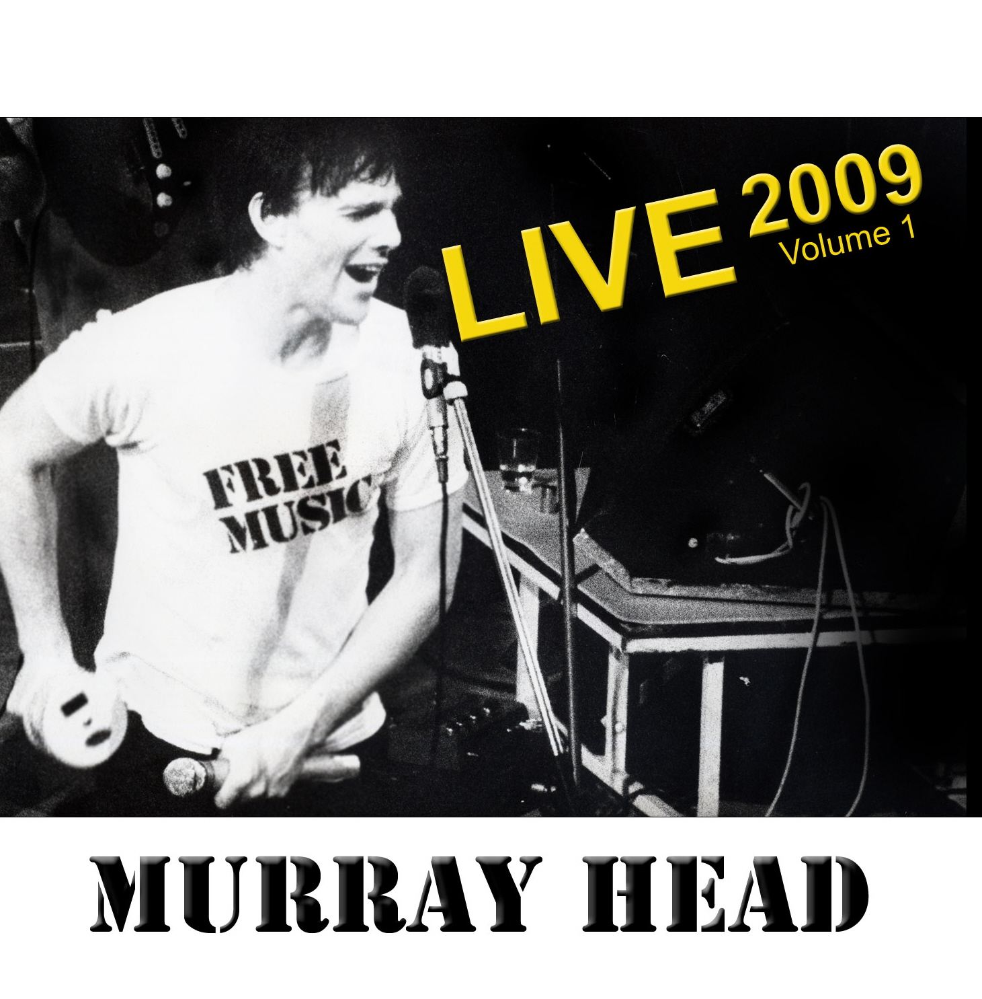

Live recordings from 2009. Part 1 of Murray's Collect'OR aka Coffret/Scrapbook 1975-2010.

2009 You Are (Live 2009) (M.Head)
2009 When I'm Yours (Live 2009) (M.Head)
2009 Rien N'est Écrit (Live 2009) (K.Fahy-G.Luka)
2009 Los Angeles (Live 2009) (M.Head)
2009 Le Sud (Live 2009) (N.Ferrer)
2009 How Many Ways (Live 2009) (M.Head)
2009 No Mystery (Live 2009) (M.Head)
2009 Nothing To Lose (Live 2009) (M.Head-S.Fletcher-P.Whittaker)
2009 Never Even Thought (Live 2009) (M.Head)
2009 Last Days Of An Empire (Live 2009) (M.Head)
2009 Love Yourself (Live 2009) (M.Head)
2009 Corporation Corridors (Live 2009) (M.Head)

2010 Live 2009 Volume 2
Solo
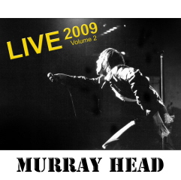

Live recordings from 2009. Part 2 of Murray's Collect'OR aka Coffret/Scrapbook 1975-2010.

2009 Countryman (Live 2009) (M.Head)
2009 Mademoiselle (Live 2009) (M.Head)
 2009 So Strong (Live 2009) (M.Feat)
2009 Will You Still Love Me Tomorrow? (Live 2009) (C.King-G.Goffin)
2009 When You're In Love (Live 2009) (M.Head)
2009 Maman (Live 2009) (M.Head)
2009 Say It Ain't So Joe (Live 2009) (M.Head)
2009 Sorry, I Love You (Live 2009) (M.Head)
2009 Joey's On Fire (Live 2009) (M.Head-P.Veitch)
2009 Bangkok / One Night In Bangkok (Live 2009) (B.Andersson-T.Rice-B.Ulvaeus)

2010 Collection Live 2009
Solo
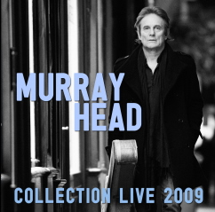

Selections from Live 2009 Volumes 1 and 2.

2009 You Are (Live 2009) (M.Head)
2009 When I'm Yours (Live 2009) (M.Head)
2009 Los Angeles (Live 2009) (M.Head)
2009 How Many Ways (Live 2009) (M.Head)
2009 Never Even Thought (Live 2009) (M.Head)
2009 Love Yourself (Live 2009) (M.Head)
2009 Corporation Corridors (Live 2009) (M.Head)
2009 Countryman (Live 2009) (M.Head)
2009 Mademoiselle (Live 2009) (M.Head)
2009 So Strong (Live 2009) (M.Feat)
2009 Will You Still Love Me Tomorrow? (Live 2009) (C.King-G.Goffin)
2009 When You're In Love (Live 2009) (M.Head)
2009 Say It Ain't So Joe (Live 2009) (M.Head)
2009 Sorry, I Love You (Live 2009) (M.Head)
2009 Joey's On Fire (Live 2009) (M.Head-P.Veitch)
2009 Bangkok / One Night In Bangkok (Live 2009) (B.Andersson-T.Rice-B.Ulvaeus)

2010 Blues & Beyond
Solo
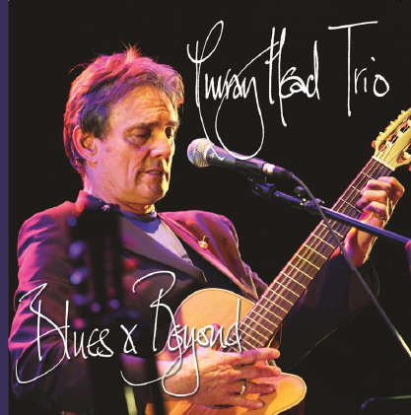

Live recordings from 2009. Part 3 of Murray's Collect'OR aka Coffret/Scrapbook 1975-
2010. Presented as a bonus disk.

2009 How Can A Poor Man Stand Such Times And Live (A.Reed)
2009 Lost My Baby Tonight (Live 2009) (M.Head)
2009 India Song (Live 2009) (M.Duras-C.d'Alessio)
2009 Dearest Anne (Live 2009) (M.Head-Y.Simon)
2009 Hesitation Blues (Live 2009) (G.Davis)
2009 Darling 1944 (Live 2009) (M.Head-C.Cohen)
2009 Cocktail Molotov (Live 2009) (M.Head-Y.Simon)
2009 Prison Wall Blues (Live 2009) (G.Cannon)
2009 Motherless Children (Trad.)
2009 Cathy's Clown (D.Everly-P.Everly)

2010 Collect'OR
Solo
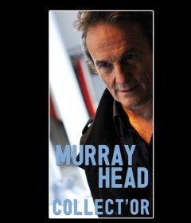

Scrapbook ("Coffret") covering Murray's concert performances from 1975 to 2010. Contains 3 CDs (Live 2009 Volumes 1 and 2 plus Blues & Beyond) + DVD (Scrapvideos 1975-2010).

2010 Scrapvideos 1975-2010
Solo

Videoclips from concerts recorded between 1975 and 2010. Part 4 of Murray's Collect'OR
aka Coffret/Scrapbook 1975-2010. Murray's commentary in French.

1975 Pacing On The Station (Live 1975) (M.Head)
1975 You Got Me Hummin' (I.Hayes-S.Porter)
 1975 I Don't Know Why I Love You (S.Wonder-P.Riser-D.Hunter-L.Hardaway)
1981 The King Of Leash (Trad.)
1981 Lady, I Could Serve You Well (Paris v2) (M.Head)
1981 Last Days Of An Empire (Paris v2) (M.Head)
1981 Losing You (Paris v2) (J.Lennon)
1981 Children Only Play (Do You Remember?) (Paris v2) (M.Head)
1981 Boy On The Bridge (Paris) (M.Head)
1981 Old Soho (Paris) (M.Head)
1981 Can't You Hear Me Knocking (M.Jagger-K.Richards)
1983 All We Can Do Is Hold On (Live 1983) (J.Sample)
1983 Corporation Corridors (Live 1983) (M.Head)
1983 Last Days Of An Empire (Live 1983) (M.Head)
1983 Rubbernecker (Live 1983) (M.Head)
1983 River Deep, Mountain High (P.Spector-J.Barry-E.Greenwich)
1984 On Your Own Again (Live 1984) (M.Head)
1984 Someone's Rockin' My Dreamboat (Live 1984) (L.Rene-E.Scott-O.Rene)
1984 Mademoiselle (Live 1984) (M.Head)
1984 Chance Encounter (Live 1984) (M.Head)
1984 Maman (Live 1984) (M.Head)
1984 Never Even Thought (Live 1984) (M.Head)
1984 With Or Without Me (Live 1984) (M.Head)
1984 Don't Forget Him Now (Live 1984) (M.Head)
1984 Peril In Venice (Live 1984) (M.Head-P.Veitch-P.Palmer)
1984 Joey's On Fire (Live 1984) (M.Head-P.Veitch)
1984 Hold Me (Live 1984) (M.Head)
1984 I Don't Care (Live 1984) (M.Head)
1984 Sorry, I Love You (Live 1984) (M.Head)
This recording also accompanies the final credits on Scrapvideos
1985 When You're In Love (Live 1985) (M.Head)
1993 Wake Up (M.Head)
Sketch in which Murray wakes up the band one by one.
1993 Rubbernecker (Live 1993) (M.Head)
1993 Los Angeles (Live 1993) (M.Head)
1993 Don't Forget Him Now (Live 1993) (M.Head)
1993 Move Closer (Live 1993) (P.Nelson)
1993 All Eyes Are On The West (Live 1993) (M.Head)
2009 Love Yourself (Live 2009 v2) (M.Head)
2009 Joey's On Fire (Live 2009 v2) (M.Head-P.Veitch)
2009 Bangkok / One Night In Bangkok (Live 2009 v2) (B.Andersson-T.Rice-B.Ulvaeus)
2009 Say It Ain't So Joe (Live 2009 v2) (M.Head)

2010 You Can’t Judge A Book By Its Cover
Solo



Free download from www.murrayhead.fr.

2010 You Can’t Judge A Book By Its Cover (W.Dixon)

2010 Episode ONE
Various Artists
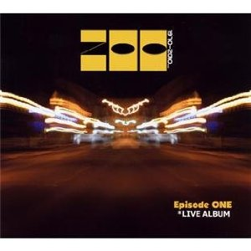
Live album by Zoo with guest artists.

2010 What Am I To Be (I.Bellamy)
Guest appearance on Zoo's 40th anniversary live album
2010 Spinning Wheel (D.Clayton-Thomas)
Guest appearance on Zoo's 40th anniversary live album

2010 Outsider
Solo
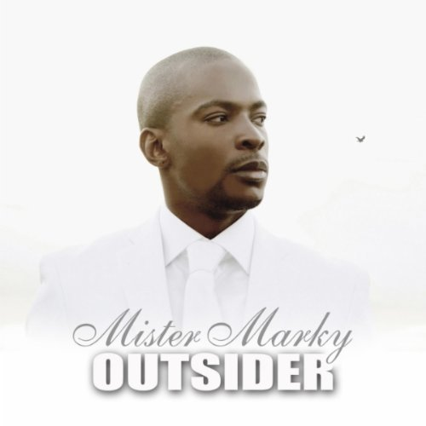
By Mister Marky

2010 Frères de Sang (M.Head-M.Marky)
With Mister Marky. Rap mixed with snippets from 'It's So Hard Singing The Blues'.

2012 V.I.P. (Very Intimes Poteaux)
Various Artists
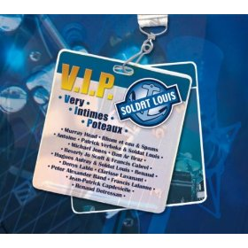
Various artists. Tribute album to Louis Soldat.

2012 T'es Mon Secret (G.Wicknam-S.Danet)

2012 My Back Pages
Solo
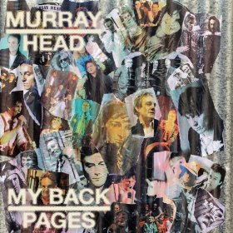

New album of cover versions.

2012 One, Two, Three (L.Borisoff-J.Madara-D.White-B.Holland-L.Dozier-E.Holland)
Cover version of Len Barry's 1965 hit.
2012 Gimme Some Lovin' (S.Winwood-S.Davis-M.Winwood)
Cover version of Spencer Davis Group's 1966 hit.
2012 My Back Pages (B.Dylan)
Cover version of The Byrds' 1967 hit, first recorded by Bob Dylan.
2012 Goin' Back (C.King-G.Goffin)
Cover version of The Byrds' 1968 hit, first recorded by Carole King & Gerry Goffin.
2012 Games People Play (J.South)
Cover version of Joe South's 1969 hit.
2012 Won't Get Fooled Again (New Version) (P.Townshend)
Cover version of The Who's 1971 hit.
2012 Dust In The Wind (K.Livgren)
Cover version of Kansas' 1977 hit.
 2012 How Do You Stop (D.Hartman-A.Kaufman)
Cover version of James Brown's 1986 hit. Track 8 on My Back Pages; incorrectly listed as Track 9 on CD sleeve.
2012 Avalon (B.Ferry)
Cover version of Roxy Music's 1982 hit. Track 9 on My Back Pages; incorrectly listed as Track 8 on CD sleeve.
 2012 Beds Are Burning (P.Garrett-R.Hirst-J.Moginie)
Cover version of Midnight Oil's 1987 hit.
2012 You Gotta Be (A.Ingram-D.Weeks)
Cover version of Des'ree's 1994 hit.
2012 Missing (T.Thorn-B.Watt)
Cover version of Everything But The Girl's 1995 hit.
 2012 White Flag (D.Armstrong-R.Armstrong-R.Nowels)
Cover version of Dido's 2003 hit.

2012 Nigel Lived (Vinyl Replica)
Solo
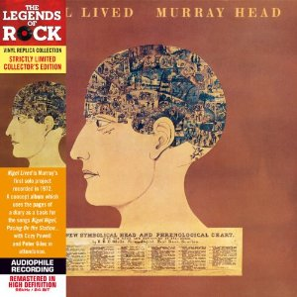

Limited edition paper sleeve CD. Vinyl replica of Nigel Lived LP (1972). Identical track list.

 Click here to view video trailer/taster..

2012 Say It Ain’t So (Vinyl Replica)
Solo
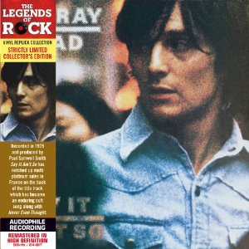

Limited edition paper sleeve CD. Vinyl replica of Say It Ain’t So (1975). Identical track list.

2012 Between Us (Vinyl Replica)
Solo
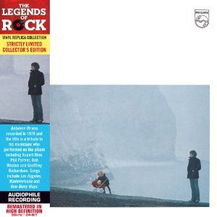

Limited edition paper sleeve CD. Vinyl replica of Between Us (1979). Identical track list.

2012 Voices (Vinyl Replica)
Solo
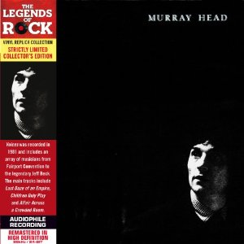

Limited edition paper sleeve CD. Vinyl replica of Voices (1980). Identical track list.

2012 Find The Crowd (Vinyl Replica)
Solo
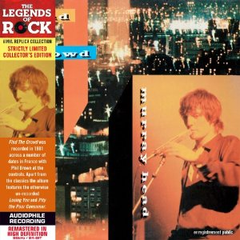

Limited edition paper sleeve CD. Vinyl replica of Find The Crowd (1981). Identical track list.

2012 Shade (Vinyl Replica)
Solo
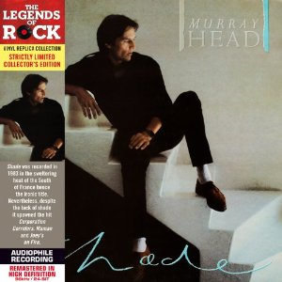

Limited edition paper sleeve CD. Vinyl replica of Shade (1982). Identical track list.

2012 There And Back
Unofficial

1965 Cocaine Blues FIRST RECORDING
1967 She Was Perfection EARLY SINGLE
1970 The Last Supper JESUS CHRIST SUPERSTAR
1972 Religion NIGEL LIVED
1975 Rainsong RAINDOG
1975 Boy On The Bridge SAY IT AIN'T SO
1979 Los Angeles BETWEEN US
1979 Sorry, I Love You BETWEEN US
1980 Dearest Anne COCKTAIL MOLOTOV
1980 Chance Encounter VOICES
1981 Pity The Poor Consumer (Live) FIND THE CROWD
1982 With Or Without Me POUR CENT BRIQUES T'AS PLUS RIEN
1984 Bangkok / One Night In Bangkok CHESS
1985 Please Don't Leave Me Now THE FLYING DEVILS
1988 Still In Love With You A GAUCHE EN SORTANT DE L'ASCENSEUR
1993 When You're In Love INNOCENCE
1996 SOS World LES ENFANTS DU FUTUR
2004 Never Even Thought EMOTIONS
2006 Crystal Heart TETE A TETE
2009 So Strong (Live) LIVE 2009 VOLUME 2
2012 Beds Are Burning MY BACK PAGES
2008 Now And Forever RIEN N'EST ECRIT
2006 Make It Easy EMOTIONS
2002 Un Homme Qui Passe CINDY
1995 Shadows Of The Truth PIPE DREAMS
1992 All Eyes Are On The West WAVE
1986 In The Heart Of You SOONER OR LATER
1984 Pity The Child CHESS
1984 Hold Me RESTLESS
1982 All We Can Do Is Hold On SHADE
1981 Going Home VOICES
1980 Last Days Of An Empire VOICES
1980 Cocktail Molotov COCKTAIL MOLOTOV
1979 Mademoiselle BETWEEN US
1978 Woman, I Love You MADEMOISELLE B-SIDE
1975 Say It Ain't So Joe SAY IT AIN'T SO
1972 Junk NIGEL LIVED
1970 Superstar JESUS CHRIST SUPERSTAR
1967 Celestial City DIMINISHING PERSPECTIVE
1966 It Ain't Me Babe TOP SONG POP HITS VOL.2

Home compilation / playlist of favourite tracks (marked  in discography), plus that Bangkok song.
40 songs, 180 minutes, 5 decades: 1965-1974, 1975-1984, 1985-1994, 1995-2004 and 2005-2014.
And now for something completely useless: 100 ‘Murraygrams’

Affair Across A Crowded Room | ---> | Coward Corridor Safe As Foam
African Tourists | ---> | Unfair To Racists
Alberta | ---> | Late Bar
All Eyes Are On The West | ---> | Lonely Sweetheart Sea
All The Way | ---> | Hate Wally!
All We Can Do Is Hold On | ---> | Sad Hill - Canoodle Now
Beds Are Burning | ---> | Absurd Beginner
Can't You Hear Me Knocking | ---> | Make Out On Angry Chicken
Caprice | ---> | Cap Eric!
Catching Eddie At It | ---> | Nit, Git, Acidhead, Etc.
C'est Fou | ---> | UFO Sect
Chanteur de Jazz | ---> | Jez Had Nut Craze
Cocaine Blues | ---> | Ace Club Noise
Cocktail Molotov | ---> | A Vomit Clock Tool
Corporation Corridors | ---> | Porno Riot Or Acid Corrs?
Countryman | ---> | My Acorn Nut
Crystal Heart | ---> | Ratty Charles
Damned For All Time / Blood Money | ---> | Lobotomy Made Me Fine Landlord
Darling 1944 (Un Été d'Orages) | ---> | Gerald United 9441 Oranges!
Dearest Anne | ---> | Tense Andrea
Diminishing Perspective | ---> | The Indecisive Pimp Grins
Do I Love Her? | ---> | Idle Hoover
Don't Forget Him Now | ---> | Moron Ted Won Fight
Don't Have To | ---> | Do That Oven!
Don't Sing No Sad Songs For Me | ---> | Daft Moron Signs Ogden's Son
Douce France | ---> | Cured Of Acne!
Dragonfly | ---> | Flog Randy!
Dust In The Wind | ---> | Did The Nuts Win?
Elle l'Attendra | ---> | A Tell-Tale Nerd
Endgame | ---> | Mad Gene
Envoie-Moi Vers Les Étoiles | ---> | I Vote Senile, Servile Moose
Everything's Alright | ---> | Harry Gives It Length
Fear And Ambition | ---> | Mortified Banana
Frères de Sang | ---> | Serf Grenades
Gimme Some Lovin' | ---> | O Lemming Movies!
Hesitation Blues | ---> | This Obtuse Alien
I Don't Care | ---> | Dance Riot
I Don't Know Why I Love You | ---> | Low View On Hooky Nudity
In The Heart Of You | ---> | Hot Feather In You
Innocence | ---> | Nicene Con?
Is That All There Is | ---> | Last Irish Athlete
It's A Dream | ---> | Mad Satire
It's So Hard Singing The Blues | ---> | Lesbian Thugs Hid Son's Tiger
Joey's On Fire | ---> | O Joy! Free Sin!
Judas' Death | ---> | Adjust Head!
Just Enough | ---> | June's Tough
La Cabane du Pêcheur | ---> | Replace A Bad Eunuch
La Route à L'Envers | ---> | Unreal Elevators
Lady I Could Serve You Well | ---> | A Ludicrously Lovely Weed
Lana Turner | ---> | Unreal Rant
Last Days Of An Empire | ---> | Tone-Deaf Liars Zap Me
Latitudes Pour Lassitude | ---> | Ultra-Stupid Lotus Disease
Le Temps Passe | ---> | Pete's Samples
Le Temps S'en Fout | ---> | Teflon Upsets Me
Little Bit Of Loving | ---> | Bottle Vigil In Loft
Little One | ---> | Toilet Len
Loin Demain | ---> | I Nail Demon
Los Angeles | ---> | Legs On Sale
Losing You | ---> | Guys In Loo
Lost My Baby Tonight | ---> | Tangibly Shy Bottom
Mademoiselle | ---> | Male Melodies
Merano | ---> | Moaner
Modern Boy | ---> | Don Embryo
My Back Pages | ---> | Packs May Beg
No Mystery | ---> | Stormy Yen
Now And Forever | ---> | Frown Over Dean
Ocean | ---> | Canoe
Old Soho | ---> | Loo Dosh
On Your Own Again | ---> | A Young Raw Onion
One, Two, Three | ---> | Wore No Teeth
One-Sided Love | ---> | Even Dodos Lie
Pacing On The Station | ---> | Cheating Saint On Pot
Peril In Venice | ---> | Vile Recipe Inn
Picking Up The Pieces [Radio Edit] | ---> | I Peep Up Git's Chicken [Dear Idiot]
Pity The Poor Consumer | ---> | Hypocrites Mourn Poet
Prison Wall Blues | ---> | Blair Sells Up Now
Quand Tu T'en Iras | ---> | Quarantine Stud
Rainsong | ---> | Sin Organ
River Deep, Mountain High | ---> | Providing Healthier Menu
Rubbernecker | ---> | Bruckner Beer
Secondhand Monday | ---> | Noddy, Men And Chaos
Sedentary Nomad | ---> | Dr Needs Anatomy
Seras-Tu Là ? | ---> | Lust Areas
Shades Of The Prison House | ---> | Hash, Heroin & Soft Dope - Uses
She Was Perfection | ---> | Cheap Wine Forests
Silence Is A Strong Reply | ---> | Priceless Learning Toys
Someday Soon | ---> | Moody Season
Someone's Rocking My Dreamboat | ---> | I'm A Crooked Bogey-Man's Monster
Sorry, I Love You | ---> | Your Rosy Olive
Strange Thing Mystifying | ---> | Thirty Gangs In Finest Gym
T'es Mon Secret | ---> | Cement Stores
The Last Supper | ---> | The Paper Sluts
Tournent Les Vents | ---> | Nutter Sent Novels
What Am I To Be | ---> | Obama The Wit
When I'm Yours | ---> | Show My Urine?!
When They Found Eldorado | ---> | Fly Due North, Woodenhead!
White Flag | ---> | Gift Whale
Who Loves You | ---> | Oh You Wolves!
With A Passion | ---> | Who's A Pianist?
You Gotta Be | ---> | Guy Ate Boot

